16th Amendment

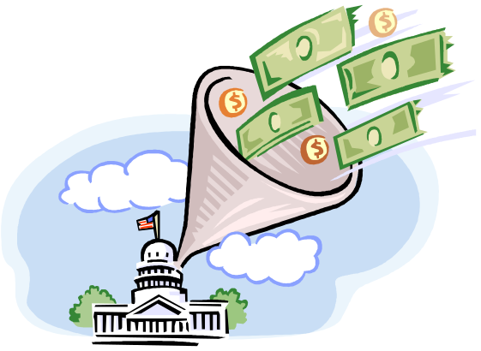

The 16th Amendment to the United States Constitution (1913) gave Congress the power to tax income.

17th Amendment


Senate
The 17th Amendment to the United States Constitution guaranteed the direct election of Senators by the voters. In the case of a vacancy, a special election is called to fill the vacancy.

1877



Military Reconstruction ended in the South with the Compromise of 1877.

1898
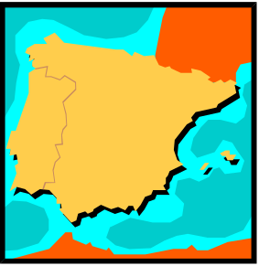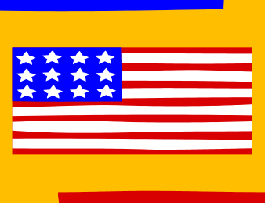

The Spanish-American War was triggered by the explosion of The Maine on February 15, 1898 in Havana, Cuba.

1914 – 1918

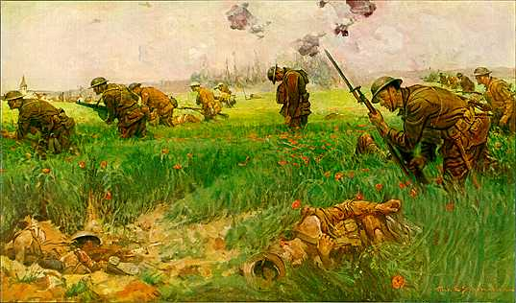

The years of World War I which was triggered by the assassination of Archduke Ferdinand and ended with the Treaty of Versailles.

1929



On Black Tuesday, October 24, 1929, the stock market crashed. The collapse of the stock market preceded a worldwide economic depression.

1941-1945

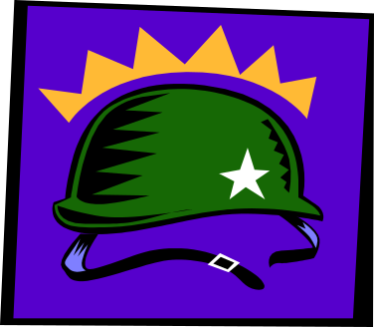

The years of U.S. involvement in World War II, which began with the Japanese attack on Pearl Harbor and ended with the U.S. bombing of Hiroshima and Nagasaki.

1957

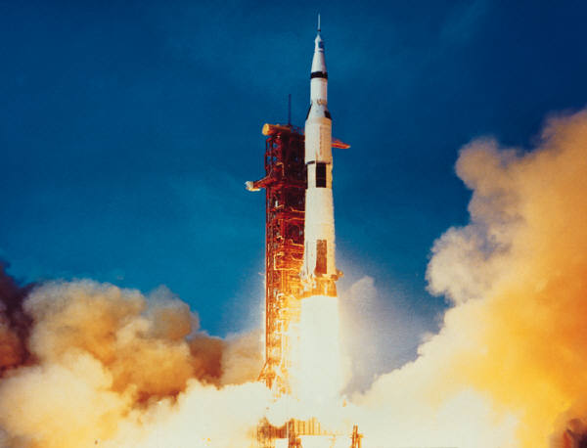

The start of the space between the United States and the Soviet Union which began with the Soviet launch of the world’s first satellite, Sputnik.

19th Amendment

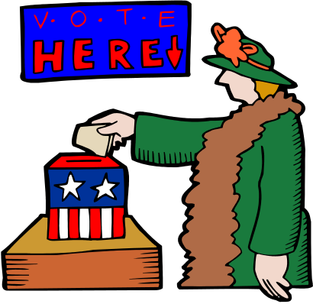

The 19th Amendment to the U.S. Constitution (1920) extended the right to vote to women in federal or state elections.

24th Amendment



The 24th Amendment to the U.S. Constitution (1964) eliminated the poll tax as a prerequisite to vote in national elections.

26th Amendment


The 26th Amendment to the U.S. Constitution (1971) lowered the voting age to 18 thereby allowing a greater percentage of U.S. citizens to participate in the process of government.

Battle of the
Argonne Forest

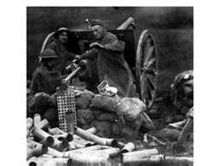
The last major offensive of World War I under General Pershing where 1/10 of all U.S. troops died over a period of 42 days due to rough terrain, heavy machine gun fire, and inadequate training.

Brown vs. Board
Of Education

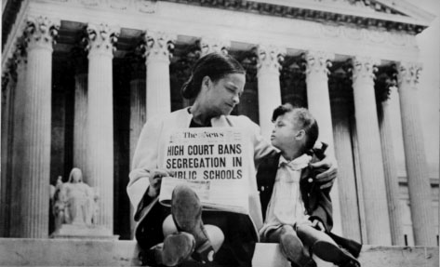

In 1954, the Supreme Court outlawed racial segregation in public schools with this landmark case that reversed the Plessy v. Ferguson (1896) decision of “separate but equal.”

Child Labor

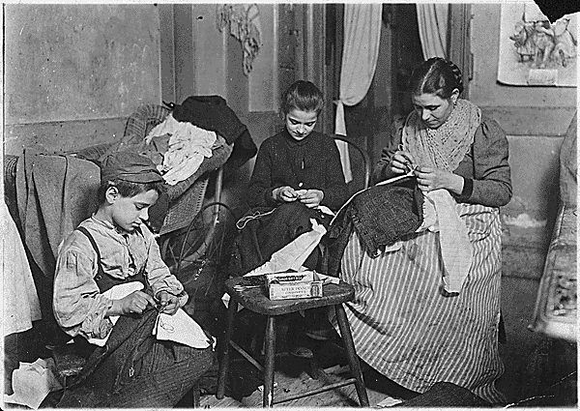

Children were viewed as laborers throughout the 19th century. Many children worked on farms, small businesses, mills and factories.

Civil Rights Act
Of 1964

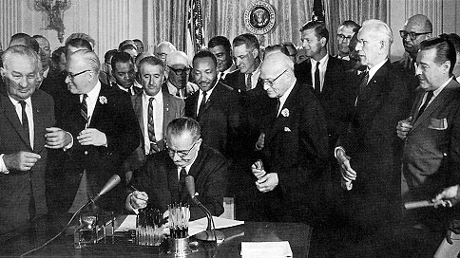
This act made racial, religious, and sex discrimination by employers illegal and gave the government the power to enforce all laws governing civil rights, including desegregation of schools and public places.

Civil Rights Movement

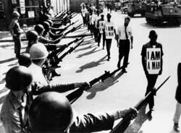
African Americans sought equality before the law and protection of their rights. Black activists, often affiliated with church groups, offered passive resistance to unjust civil laws.

Civil Service Reform

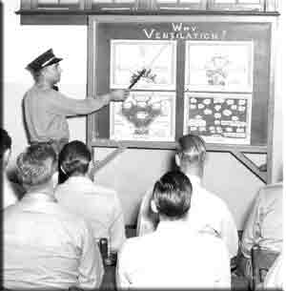

Congress took action in the late 19th century to protect ethical politicians and create standards for political service; including, a civil service test for those seeking a job in government.

Cold War

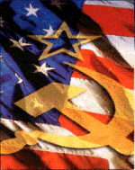

Following World War II the United States and the Soviet Union emerged as superpowers. The two unions of states faced off in an arms race that lasted nearly 50 years.

Conservation of Natural Resources


Preserving natural resources by limiting commercial development and ensuring their wise use. Areas of scenic beauty, or scientific, geological, or biological interest are preserved as parks.

Demographic Patterns



The study of population and the forces that affect change within population, like birth and death rates.

Dictatorships

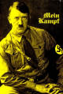
A dictator is a ruler who wields absolute authority and controls the government within a state or nation, like Hitler in Germany, Mussolini in Italy, and Stalin in the Soviet Union.

Dollar Diplomacy


A policy adopted by President Taft to encourage investment by American banks and businesses foreign countries. He promised military protection to those who invested abroad.

GI Bill of Rights

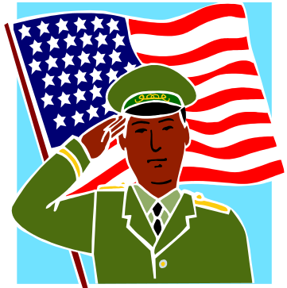

Also known as the Servicemen’s Readjustment Act, this bill allotted funds to send former soldiers to school. In 10 years after World War II, 8 million veterans went to school at government expense.

The
Great
Depression

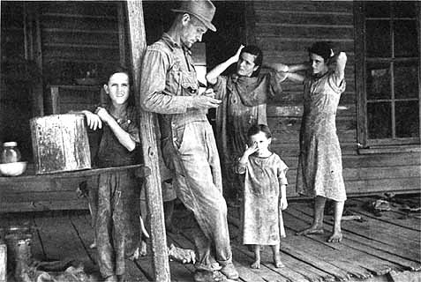

A period of severe economic hardship that began with the stock market crash in 1929 and continued until World War II. Banks failed and too many people had too little money to make ends meet. Many Americans were unemployed.

The
Great Plains

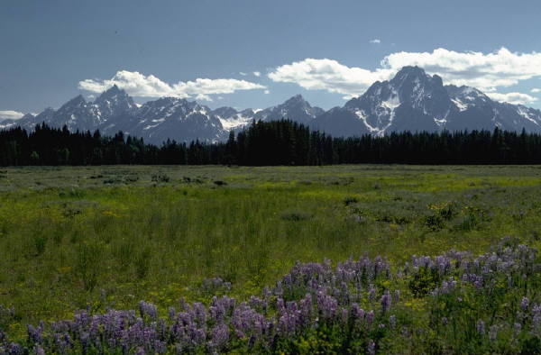

A high grassland region of central North America extending south from the Canadian provinces of Alberta, Saskatchewan, and Manitoba to Texas.

Growth of Labor Unions

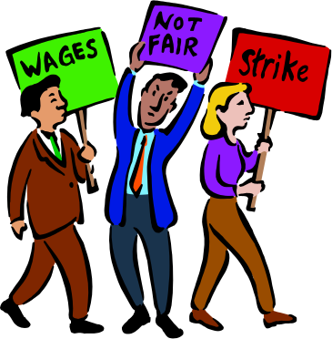

As industrialization increased the rights of laborers were undermined an emphasis on production and profit. Workers unionized to seek better wages, hours and improved working conditions.

Gulf of Tonkin Resolution

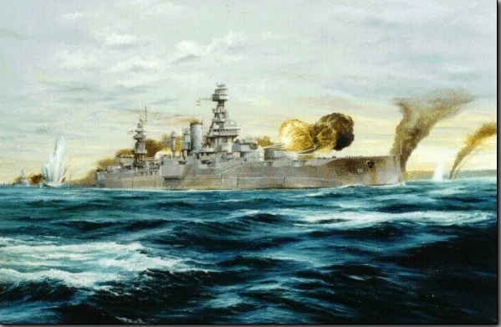

Prompted by reports of North Vietnamese aggression against an American warship, Congress authorized President Johnson to increase American military involvement in Vietnam.

Harlem Renaissance

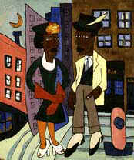
A rebirth of African-American culture led by poets, authors, artists, musicians, and movie stars and provided an outlet for African-American intellectuals who continued to oppose racial segregation and suppression.

Immigrants

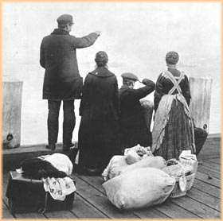

Immigration to the United States increased steadily from 1850 to 1900. More than 5 million people entered in the 1880’s, swelling urban populations.

Indian Policies



Due to efforts to assimilate Native Americans, including the Dawes Act (1887), the traditions of Native Americans disappeared as they were removed from their homelands, isolated on reservations, and forced to abandon their rituals.

Initiative

A process by which special interest groups, through voter participation, can propose bills to their legislature for a vote. Voters can force lawmakers to deal with difficult issues.

Interstate Commerce Commission

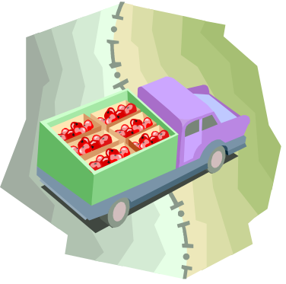

Established by an act of Congress in 1887, this outlawed discrimination against shippers and the practice of one carrier charging more for short hauls than for long ones.

Korea

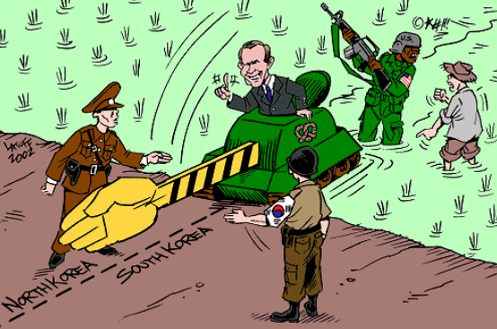
A nation in northern Asia divided following World War II between North Korea and South Korea and separated since 1953 by a demilitarized zone policed by U.S. and North Korean troops.

McCarthyism

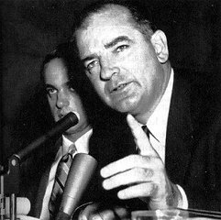

The fear of communism increased throughout the 1950’s as Americans became sensitized to the threat through publicized investigations of critics of the government led by Senator Joseph McCarthy.

The New Deal

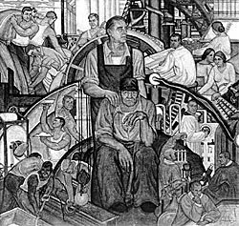

FDR’s plan to end the Great Depression. Bills passed during the first 100 days of his presidency in 1933 stressed “the 3 R’s” of relief, recovery, and reform.

Open Door Policy

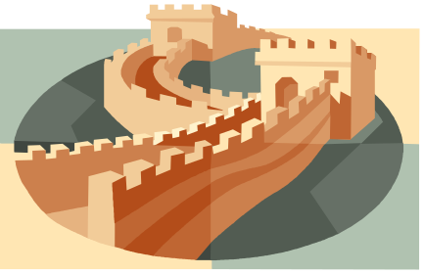

A United States trade policy with China that stated that all nations would have equal trading rights in China. (1899-1900)

Panama Canal

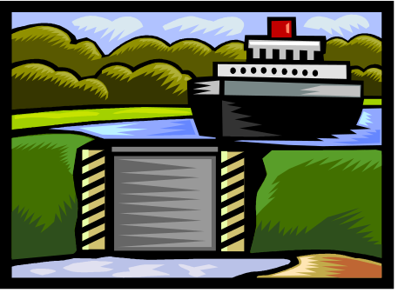
In 1901 the Hay-Pauncefote Treaty gave the U.S. the right to construct and defend a canal through Central America in order to have safer, quicker access to the east from the west.

Political Machines

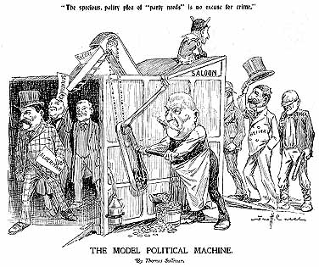

Informal organizations that control formal processes of government through bribery and force. Friends are rewarded with jobs within in the government in a process called the “spoils system.”

Progressive Era

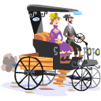
A political movement in the early 1900’s which saw reform efforts such as child labor laws, minimum wage, rights for women, and political reforms such as initiative and referendum.

Prohibition



Enforced by the 18th Amendment to the U.S. Constitution (1919), it became illegal to manufacture, sell, or transport alcoholic beverages.

Recall

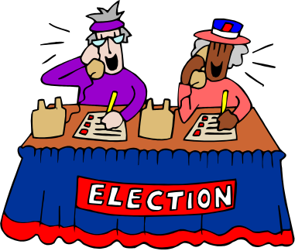
Voters hold the power to remove a public official from office before the next scheduled election. This process developed out of the political reform movements of the Progressive Era.

Red Scare

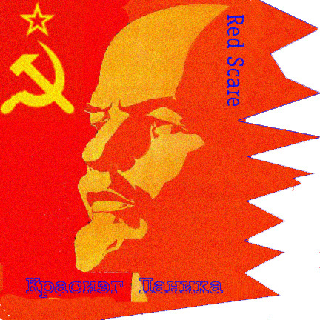
Paranoia regarding the threat of Bolsheviks to the United State from 1919-1920. Many people were charged with crimes, deported, or executed because of their political beliefs.

Referendum



A process by which voters approve bills offered by the legislature. Controversial bills such as tax increases can be put to a public vote before coming law.

Regents of the University of California v. Bakke



In 1978, the Supreme Court ruled that Allan Bakke was a victim of reverse discrimination. The court did not overturn “affirmative action,” preferring to take discrimination questions on a case-by-case basis.

Reynolds v. Sims

1 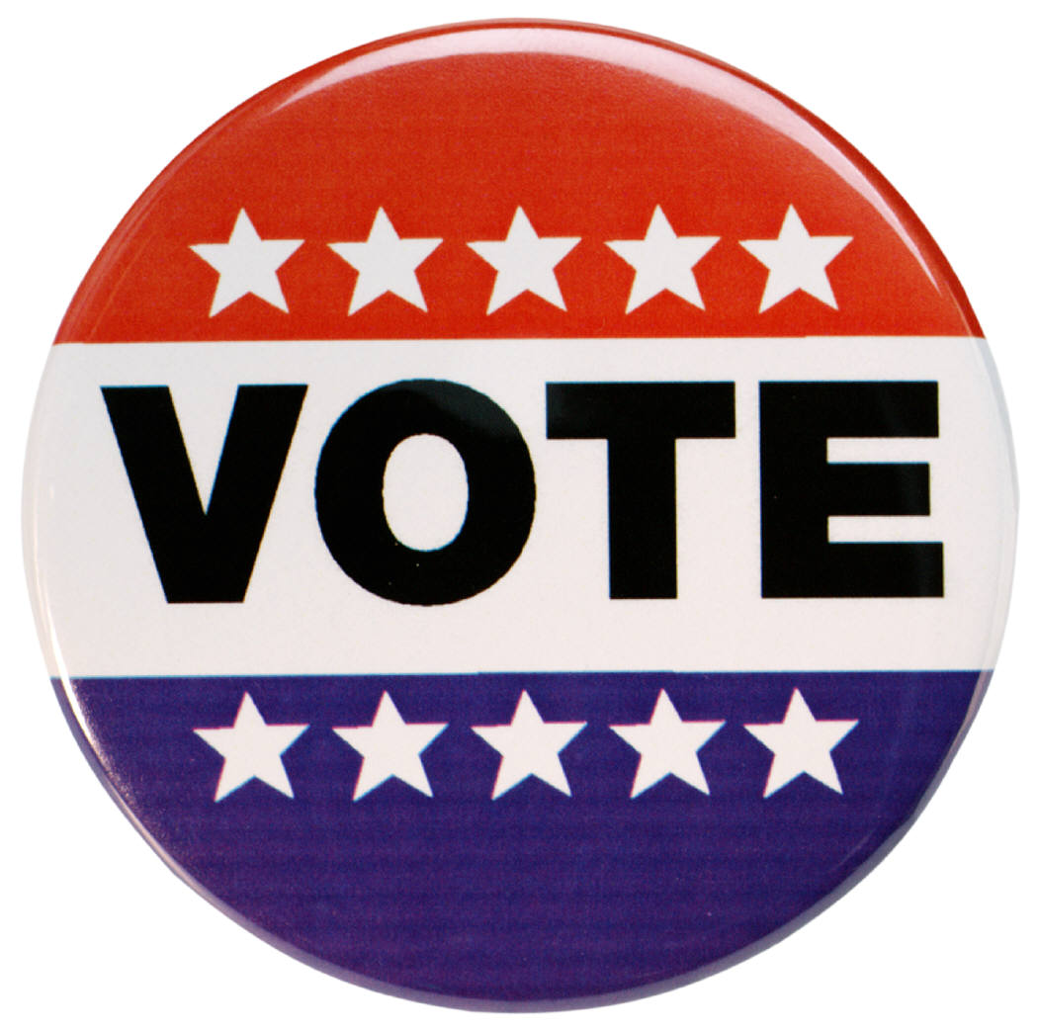

The Supreme Court ruled that the House of Representatives and all state and local bodies had to be apportioned on a “one-man to one-vote” principle, further supporting equal representation in American government.

Rock and Roll


A popular style of music started in the 1950’s with roots in rhythm-and-blues, jazz, country and folk music. Early musicians included Little Richard, Chuck Berry, Buddy Holly and Elvis Presley.

Sherman Anti-Trust Act

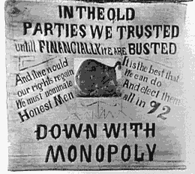

Passed in 1890, in an effort to control monopolies, this act outlawed efforts to consolidate businesses under trusts that monopolized and restrained free trade.

Soviet Aggression

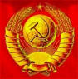

In 1922 the communists created the U.S.S.R. European countries and the U.S. feared that communist expansion threatened established governments, particularly democracies in Europe.

Sputnik I

Sputnik was the first space satellite. Launched in 1957 by the Soviet Union government under Nikita Khrushchev, it started the space race with the United States.

Teapot Dome

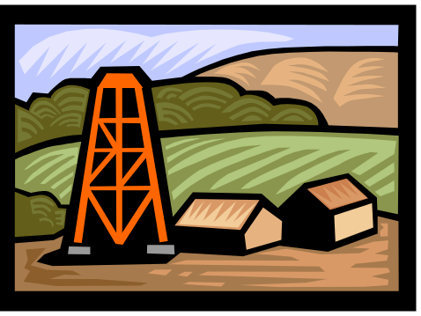

A scandal in the administration of President Harding. The Secretary of the Interior, Albert G. Fall leased oil reserves in Wyoming to oilmen who paid him kickbacks worth hundreds of thousands of dollars.

The Grapes of Wrath

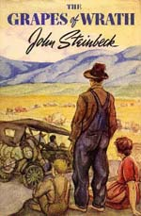

A novel by John Steinbeck portraying the plight of migrant agricultural workers in California during the Great Depression and the Dust Bowl.

Third Parties

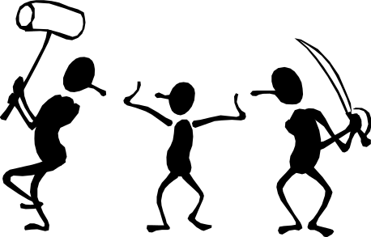

Third parties offer a voice to those seeking to reform the dominant two-party system of government in the United States. They reflect an interest in change and often contribute new political ideas.

Treaty of Versailles

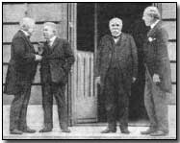
The treaty written by allied leaders that ended World War I and created the League of Nations and charged Germany with the responsibility for the war and ordered reparations be paid to the allied nations.

U.S. Expansion

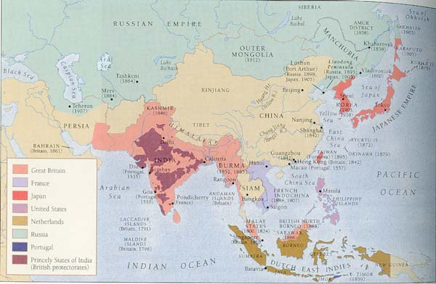

The policy of the United States during the 19th and 20th centuries to expand into foreign markets in exchange for military protection.

U.S. Free Enterprise System

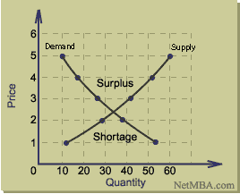
An economic system in which individuals depend on supply and demand and the profit margin to determine what to produce, how to produce, how many to produce and for whom to produce.

Vietnam

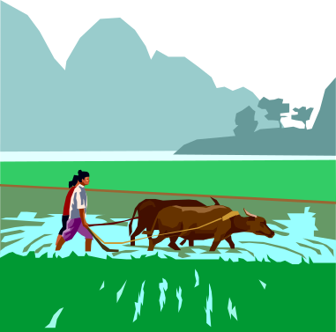

In the 1950's, the United States began to send troops to Vietnam, during the following 25-year period, the ensuing war would create some of the strongest tensions in US history. In total, it is estimated that over 2.5 million people on both sides were killed.

War Powers Act


The War Powers Act, passed by Congress in 1973, required the President to inform Congress within two days of any use of American troops I a foreign country and to withdraw the troops within 60 days if Congress did not support the deployment.

Henry Ford

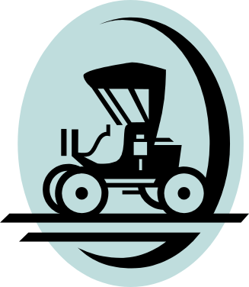

(1863-1947)
Henry Ford helped create a mobile society by mass producing and marketing the automobile, making it an indispensable part of American life.

General Dwight D. Eisenhower

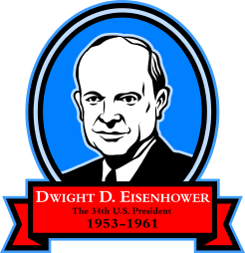

(1890-1969)
General Eisenhower served his country as Allied Commander in Europe during WWII and as President of the United States from 1952 to 1960.

W. E. B DuBois
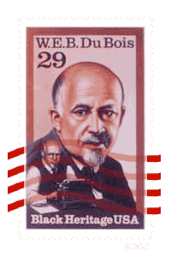
NAACP
(1969-1962)
W.E.B. DuBois believed in the ability of the Talented Tenth, intellectual black elites, to advance the cause for all blacks. He was instrumental in the establishment of the National Association for the Advancement of Colored People (NAACP).

Eugene V. Debs

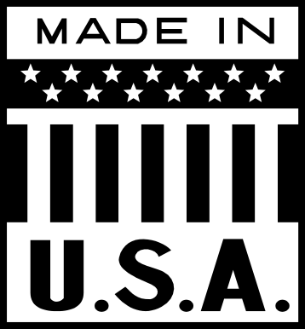
(1855-1926)
Eugene V. Debs supported unionization and labor reforms, opposed strikes and favored negotiation as a means to improve conditions for workers.

Clarence Darrow

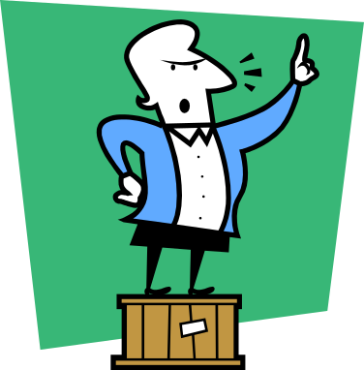
(1857-1938)
The most renown defense attorney of his time; defended John T. Scopes who was charged by fundamentalists for violated a Tennessee statute against teaching evolution in schools.

Shirley Chisholm

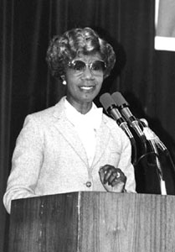
- )

The first African-American woman elected the U.S. Congress and the first to run as a candidate for president.

Andrew Carnegie



(1835-1919)
One of the richest men in the world who shared his wealth to worthy causes aiding education, international peace, libraries, culture centers, research and publications.

William Jennings Bryan



(1860-1925)
A noted politician and orator who supported reforms such as income tax, prohibition and women’s suffrage. He served as spokesman for the prosecution in the Scopes trial on evolution in schools.

Omar Bradley



(1893-1981)
A U.S. Army general noted for his concern for individual soldiers and his ability to organize troops during World War II. He commanded the First Army in the D-Day and Normandy campaigns.

Susan B. Anthony
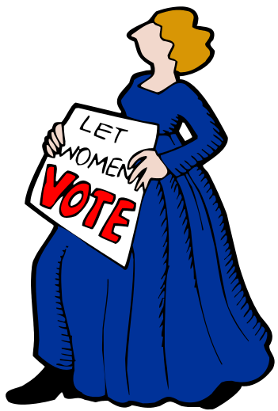

(1820-1906)
Susan B. Anthony was a leading force in the women’s suffrage movement for 50 years.

Unrestricted Submarine Warfare

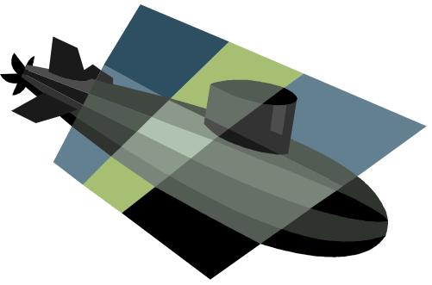
After years of neutrality during World War I, the U.S. entered the war because of Germany’s attempt to try to dominate sea power in the Atlantic Ocean using unrestricted submarine warfare.

George Wallace

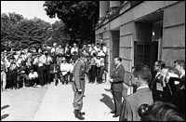
(1919-1998)
George Wallace was Governor of Alabama in 1963 when African-American students sought admission to the University of Alabama. He literally barred the door, denying them admission. This prompted non-violent protests including sit-ins, boycotts, and marches.

Harry S. Truman

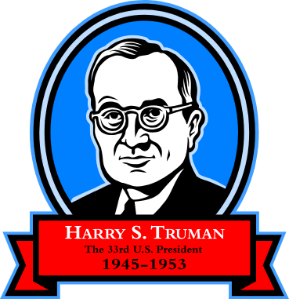
(1884-1972)
Harry S. Truman assumed the presidency following the sudden death of FDR. He authorized the use of the atomic bomb in Japan in World War II, and announced the Truman Doctrine, which pledged U.S. support to nations opposing communism.

Theodore Roosevelt

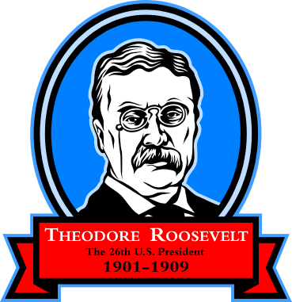

(1959-1919)
Gained national attention as the leader of the “Rough Riders,” during the Spanish-American War; succeeded McKinley upon his assassination; created national parks and supported passage of the Pure Food and Drug Act.

Franklin Delano Roosevelt

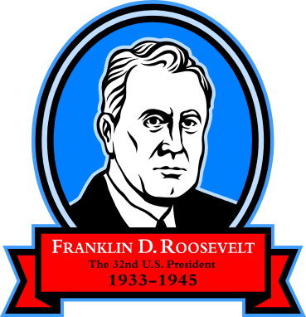

(1882-1945)
Contracted polio in 1921 and went on to become President of the United States. During his first 100 days, proposed the New Deal in an effort to counteract the effects of the Great Depression. He was President during most of World War II.

John J. Pershing

(1860-1948)
Pershing was sent to Mexico to apprehend Pancho Villa in 1914; He led the American Expeditionary Force during World War I.

H. Ross Perot

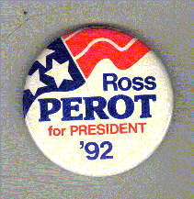
- )

Ross Perot is a successful Texas businessman who garnered third-party support for his bid at the U.S. Presidency in the 1990’s.

George Patton, Jr.

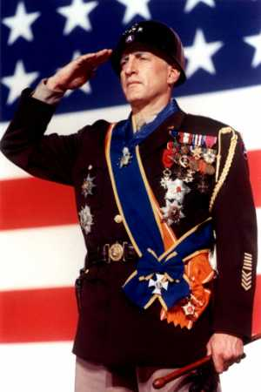
(1885-1945)
Patton directed the amphibious landings at Casablanca and the campaign in North Africa, led the Third Army out of Normandy and assisted with the Battle of the Bulge in World War II.

Georgia O’Keefe

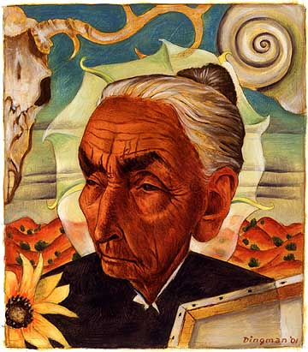
(1887-1986)
Georgia O’Keefe became the most noted representational expressionist painter in America. Her most famous works concentrated on scenes of the southwest.

George Marshall
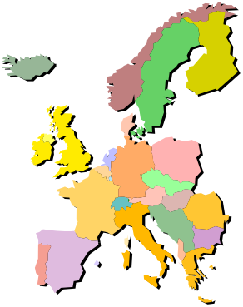
(1880-1959)
George Marshall organized the CCC of the New Deal and implemented the Marshall Plan after World War II for the economic recovery of Europe. He won the Nobel Peace Prize in 1953 for his post-war efforts.

Alfred Thayer Mahan

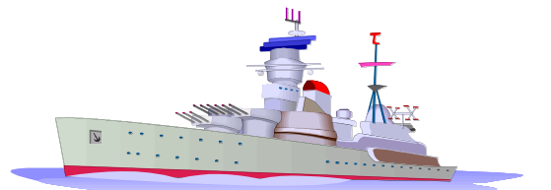
(1940-1914)
An admiral and naval historian whose theories on the relationship of sea power and world commerce influenced foreign policy development in the 1880’s and 1890’s.

Douglas MacArthur

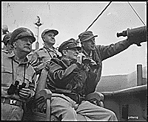
(1880-1964)
Led troops that evicted the veterans who were camped in Washington DC protesting their treatment and conditions during the Great Depression; Commander of forces in the Far East during World War II.

Henry Cabot Lodge

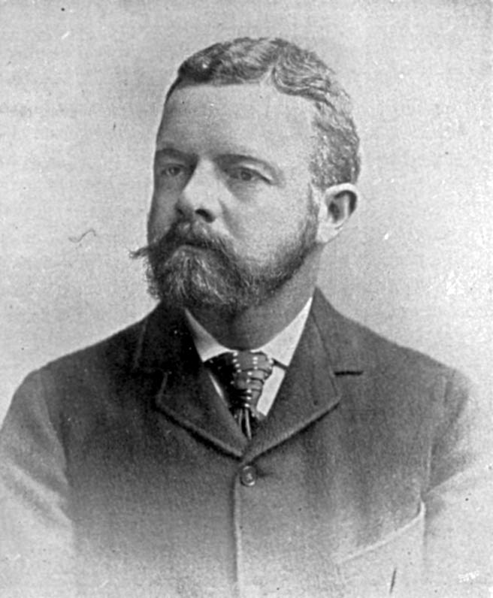
(1850-1924)
A Senator from Massachusetts supported American expansion as a way to increase national pride, spread civilizations, and thereby gain world power.

Charles A. Lindbergh

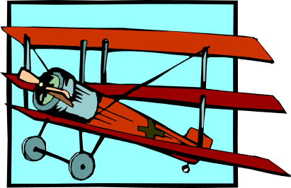

(1902-1974)
Lindbergh made aviation history when he flew the specially built airplane, The Spirit of St. Louis, nonstop from St. Louis to Paris in 1927.

Watergate

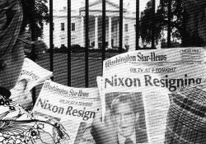

Watergate was a scandal involving the Richard Nixon administration that ended in Nixon’s resignation in 1974. The scandal involved a break-in, paid for by the Nixon campaign committee at the Democratic National Committee office at the Watergate office complex in Washington, D.C.

Dr. Martin Luther King, Jr.

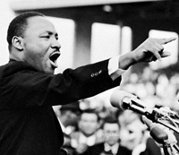

(1929-1968)
A noted leader and clergyman; one of several African-Americans concerned with reforming American society and gaining equal rights by using civil disobedience or non-violent action.

Wilson’s Fourteen Points

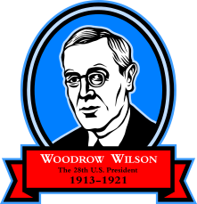
After World War I, President Wilson sought to reduce the risk of war through open covenants of peace, absolute freedom of navigation, removal of economic barriers to trade, as well as other political and economic points.

