Name: _______________________________ Period: ___________ Date: ____________
Contextualization: Star Wars Opening Crawl

- How does the clip begin? What do you learn from it?

- Once the opening crawl begins, what other information do we learn? Why do you need to know this?

- The last part of the scroll shifts to a specific person. What do we learn about her?

Let’s consider the description below which comes from the rubric for AP histories. Contextualization is a score point on both the document-based question (DBQ) and the long essay question (LEQ).
Read over this description, underline the most important words or phrases and discuss the questions that follow.

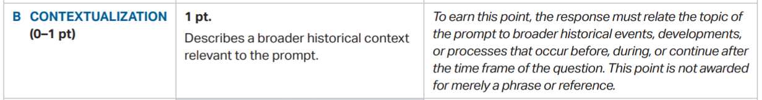
© 2017 The College Board

- How can you earn this point? Can you connect this information back to the AP historical and reasoning skills?

- By reading this description, how long do you think a contextualization statement should be? (Think back to the clip we just viewed).

Now, apply this definition to the sample:
“It is generally believed that the Americas were first settled by people from Siberia, who then remained isolated from the rest of the world for thousands of years.”

Prompt: 2018 LEQ #3
In the period 1450 - 1750, oceanic voyages resulted in the Columbian Exchange, which transformed the Eastern and Western Hemispheres.
Develop an argument that evaluates how the Columbian Exchange affected peoples in the Americas in this time period.
© 2018 The College Board

- How does this sample “relate the topic of the prompt to broader historical events, developments or processes”?

Finally, review this statement from the College Board scoring guidelines:
“Typically statements credited as contextualization will be more general statements that place an argument or a significant portion of it in a broader context.”

- Take a moment to explain contextualization in your own words:

- Do you think this activity would work for your students? Why or why not?

- How would you make modifications to this activity for your students?

Here are some steps for deconstructing any AP World History prompt:
- Label provided historical context: What is the time period you are being asked to write about?
- Circle action words: What is the task asking you to do?
- Circle underlined words: Are you paying attention to the details?
- Underline important clauses: Are there details and/or parameters for the task?
Work with your partner to list historical events, developments or processes that students need to know to answer this question. Brainstorm with your elbow partner and make a list in the space below.
- Label ALL historical events, developments or processes: What aspect of world history are you being asked to write about?
Prompt: 2018 LEQ #3
In the period 1450 - 1750, oceanic voyages resulted in the Columbian Exchange, which transformed the Eastern and Western Hemispheres.
Develop an argument that evaluates how the Columbian Exchange affected peoples in the Americas in this time period.
© 2018 The College Board

Which historical developments), historical reasoning skills and thematic learning objective(s) does the prompt address?
Remember that the thematic learning objectives are the focus of the exam questions, and answering the questions depends on students understanding how to apply knowledge of the key concepts to form an argument which employs the historical thinking skills. It is important that you use this language with your students and teach them to annotate the prompts.

- Historical Developments:

- Historical Thinking Skills:

- Thematic Learning Objectives:

STEP 2: Brain Dump

Here’s what our Star Wars opening crawl looks like in the GRL brain dump chart:
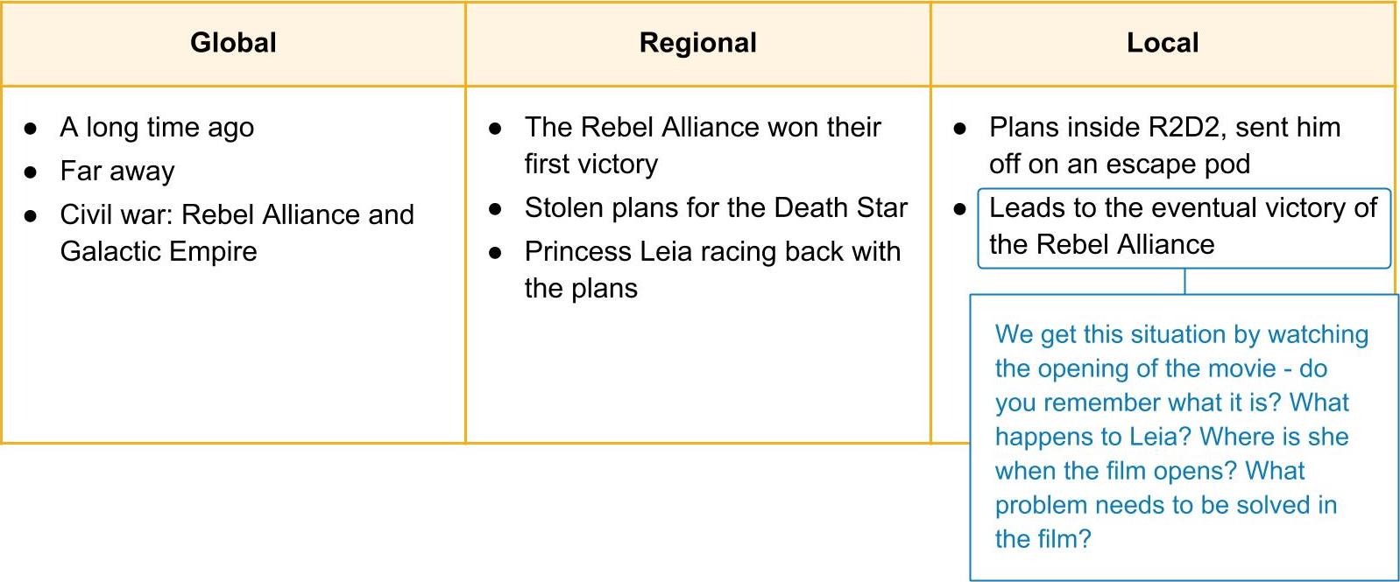

Let’s try it with our prompt. Work on the following GRL brain dump chart with a partner.

Prompt: 2018 LEQ #3
In the period 1450 - 1750, oceanic voyages resulted in the Columbian Exchange, which transformed the Eastern and Western Hemispheres.
Develop an argument that evaluates how the Columbian Exchange affected peoples in the Americas in this time period.
© 2018 The College Board

Global-Regional-Local Brain Dump Chart

First, brainstorm and list the global historical events before or during the given time period in the chart. You may want to refer to the key concepts in Activity 3. Consider this the big picture. | Next, add the regional historical events, developments or processes during the given time period. This regional set of examples will serve as the bridge between the broadest global context and the more immediate local thesis statement. | Finally, list the local specific historical events related to the indicated (or chosen) place in the prompt, keeping in mind the historical reasoning skill. This portion will be turned into a thesis statement.
Global | Regional | Local

Consider looking in your textbook or the more detailed breakdown of the key concepts in the CED.

STEP 3: Use your chart to write the contextualization: Next we will use your brainstormed ideas to develop a paragraph which forms a global and regional contextualization (1-3 sentences) and ends with a local thesis statement (1-2 sentences) in the final step. The italicized examples will come from the information we pulled together in the Star Wars chart.

Writing a Contextualization Statement

- First, look over what you brainstormed in your global context row on the chart. This will be used to write your first sentence or two.
Here’s an example:
A long time ago, in a galaxy far, far away, a civil war was raging between the Rebel Alliance and the Galactic Empire.
Notice how our statement captures the big picture of what is happening in the galaxy. Use your brainstorming to complete a 1-2 sentence global big picture statement that provides historical context for our prompt:

- Next, look over your regional context row on the chart. This information will form your next 1-2 sentences.
Example: The Rebel Alliance has just won their first victory by striking from a hidden base. They have stolen plans for the Death Star and Princess Leia is racing back to base with the plans.
We’ve moved from the big picture, to the more immediate regional situation. Use your regional context brainstorming to write the next 1 - 2 sentences.

STEP 4: Write Your Thesis
You will use your local brainstorming to make a historically defensible claim that answers the prompt. But first, here is the rubric. Read over this description, and underline the most important words or phrases:

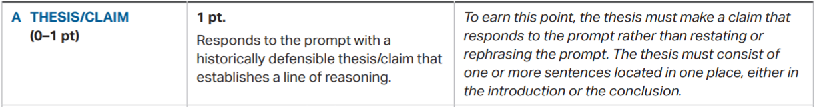
© 2017 The College Board

! | The thesis only gains a point if it appears in the introduction or the conclusion. Therefore, we are going to practice making it the final sentence or two in our opening paragraph. We’ll walk through a basic thesis (or claim).

Writing a Thesis: Star Wars Example

Let’s assume we’ve all watched Star Wars: A New Hope and filled in the local column of the Star Wars example with details from the movie.
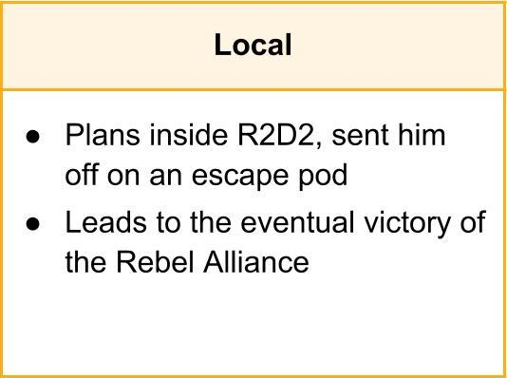
- Look over the evidence and categorize it (think of the SPICE chart). Use the broad category to begin.
In our Star Wars example, the category based on our evidence (securing plans for the Death Star) would be political - the goal of the Rebel Alliance was to defeat the Empire.

- Using the broad idea of the category, write a historically defensible thesis that establishes a line of reasoning, or a set of reasons that will allow you to reach a conclusion.
A historically defensible argument we could make about the film using our details is this: Securing the plans for the Death Star ensured the eventual victory of the Rebel Alliance.

Now you try! Take your local details in your chart and write a historically defensible thesis in 1-2 sentences. Consider the places and dates in the prompt and incorporate them here. Remember, AP stands for “answer the prompt.”

Check your thesis. Did you include the category or simply restate the prompt? Did you offer a line of reasoning?

STEP 5: Put it all together
Put all of the sentences together - global, regional, local and you’ve got the opening to your essay that if done correctly will score you 2 points. That’s ⅓ of the essay score points on the long essay question (LEQ) and 2/7 of the essay score on the document-based question (DBQ)!
Here’s our finished Star Wars paragraph:
A long time ago, in a galaxy far, far away, a civil war was raging between the Rebel Alliance and the Galactic Empire. The Rebel Alliance has just won their first victory by striking from a hidden base. They have stolen plans for the Death Star and Princess Leia is racing back to base with the plans. Securing the plans for the Death Star ensured the eventual victory of the Rebel Alliance.

Now you try! Write your contextualization statements on one notecard, and your thesis on second notecard. You will use these in the next activity.

