Genocide In the Modern World Project
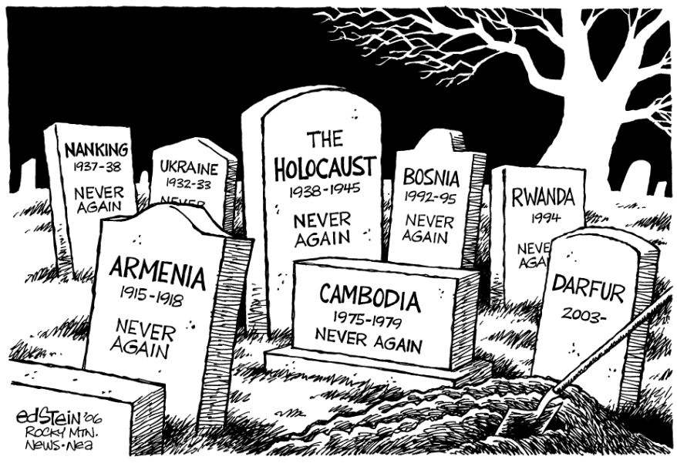
Introduction :
Often times when we think about Genocide, we think simply about the Holocaust. However, genocides have happened in many countries and continue to happen in the world today. When we look at genocides, we often see 8 stages that come together to allow the genocide to take place, justify it and ultimately also deny it. Before you begin, this project make sure you have completed the reading on the 8 stages of Genocide.

Directions:
For the project you will be researching a genocide that has occurred since 1900. You will also demonstrate and explain the how the 8 stages of genocide fit within your event. While there are numerous genocides, you will select one from the provided list.

Genocide Options:
1. Nanking Massacre
2. Armeanian Genocide
3. Rwandan Genocide
4. Cambodian Genocide
5. Holdomor (Ukrainan Genocide)
6. Darfur Genocide
Format:
Complete the project in power point or prezi

Required Elements:
- Slide 1 – Title Page (Genocide and Your Name)
- Slide 2 – Historical Background leading to the event
    - How did political climate lead to the event?
    - How did social structure/environment lead to the event?
    - Other major events that led to the genocide. (Think about countries history and such)
- Slide 3 – What happened
    - Key Players
    - How did it start?
    - Why did it start?
    - What took place during the genocide
    - Where/When did it occur?
- Slides 4-11 – 8 stages of Genocide
    - Make sure you clearly address the 8 stages of Genocide during your presentation
- Slide 12 – Outcomes
    - Statistics
    - Ramifications
    - International Response (before, during, after)
- Slide 13 – What has/can be learned from your event
- Images/Short Video on each slide – could be used as a background slide if its different for each slide
    - Include at least three images with your own explanation
    - Short video (optional) – No more than 5 minutes
***You can have information spread out on to 2 slides if needed but try not to have the project more than 20 total slides.

