Topic 1.6 p.45 GOV: Developments from Europe c. 1200 to c.1450
Directions: Annotate the graphic organizer below using textbook:

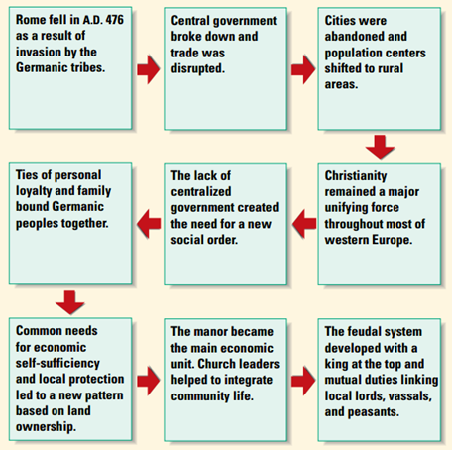

Guided Viewing Crash Course Episode 14 “The Dark Ages…How Dark Were They, Really?”https://www.youtube.com/watch?v=QV7CanyzhZg
Use these questions to annotate your Topic Page
1. Why is the period between 600 C.E. and 1450 referred to as the Dark Ages?
2. How did the political system of Europe change following the fall of the Roman Empire in the West?
3. How was feudalism also an economic system?
4. How was Dar-al-Islam different from Western Europe during the “Dark Ages”?

