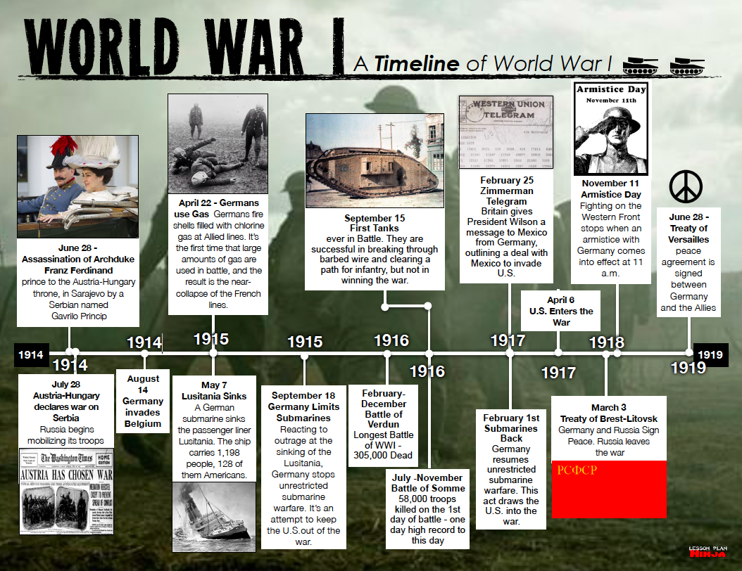
N a m e _______________________________________________________________D a t e _ __________________P e r i o d ___________
A Timeline of World War I
Analyze the timeline to answer the following questions.
1. What happened earlier? A) Austria Hungry declares war on Serbia B) Germany invades Belgium. _________________________________________________
2. What year was the Treaty of Brest-Litovsk signed? _______________________________________________________________________________________
3. What is the span (number of years shown) on this timeline?_________________________________________________________________________________
4. What event happened April of 1917? __________________________________________________________________________________________________
5. How did Germany ‘dig their own grave’ February 1st, 1917? _______________________________________________________________________________
6. What two events happened in 1918?___________________________________________________________________________________________________
7. Why did Germany limit its unrestricted submarine warfare policy? ___________________________________________________________________________
8. How many months long was the Battle of Verdun? _______________________________________________________________________________________
9. Who assassinated Archduke Franz Ferdinand? ___________________________________________________________________________________________
10. How long was the Battle of Somme? _________________________________________________________________________________________________
11. How long did it take from the assassination of Franz Ferdinand, for Austria Hungary to declare war on Serbia? ______________________________________
12. What are two events in 1917 that drove the U.S. to declare war on Germany? _________________________________________________________________
13. How many years into the war did it take for Germany to use poison gas on a large scale? ________________________________________________________
14. What was the significance of the Battle of Somme? ______________________________________________________________________________________
Matching
_____15. Treaty of Brest-Litovsk a. Zimmerman telegram
_____16. letter motivating U.S. to go to war with Germany b. Lusitania
_____17. Treaty of Versailles c. agreement to stop fighting
_____18. armistice d. agreement between Germany and Allies
_____19. destroyed by German U-boats. 128 Americans died e. agreement between Germany and Russia
_____20. deadliest battle of the war f. Somme

