The Beginning of the Industrial Revolution
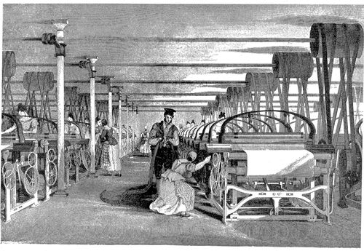
The Industrial Revolution was the transition from small cottage industries in which goods were primarily made by hand to new mass-produced goods in factories using steam and water power. The Industrial Revolution began in Great Britain around 1760 and many of the technological innovations were of British origin. Textiles were the dominant industry of the Industrial Revolution in terms of employment, value of output and capital invested. The textile industry was also the first to use modern production methods.
The Industrial Revolution marked a major turning point in history and almost every aspect of daily life was influenced in some way. There are several important reasons why it began in Great Britain.
Inventions and Innovations
One of the most important reasons the Industrial Revolution began in Great Britain was that many of the most important inventions and innovations that powered the revolution were developed there.
Initial developments occurred in the cotton industry with the development of the spinning jenny, water frame, and spinning mule. The spinning jenny was invented in 1764 by James Hargreaves in Stanhill, England. The device reduced the amount of work needed to produce cloth, with a worker able to work 8 or more spools at once. Richard Arkwright invented the water-powered water frame, which produced yarn harder and stronger than that of the initial spinning jenny. Samuel Crompton combined the spinning jenny and water frame to create the spinning mule, a machine that revolutionized the industry worldwide. The mule was the most common spinning machine from 1790 until about 1900 and was still used for fine yarns until the early 1980s.
James Watt developed perhaps the most important invention of the era with his steam engine. He improved on Thomas Newcomen’s 1712 Newcomen steam engine with his Watt steam engine in 1776. This engine was more efficient and more powerful and was soon developed further to power machines in factories as well as steamships at sea and locomotives on rails.
Soon, other industries benefited from industrialization. Other innovations included new steel making processes by Henry Bessemer, mass-production, assembly lines, electrical grid systems, and other advanced machinery in steam-powered factories
An Agricultural Revolution
England had been an agricultural nation for centuries. Crop rotation techniques had improved over that period allowing soil to remain more fertile and growing outputs increased. Farmers also experimented with livestock breeding by allowing only their largest animals to breed. This resulted in larger, healthier cattle and lamb.
In the 1700’s, wealthy landowners bought up smaller farms and enclosed their larger lands with fences. This enclosure movement led to more productive farming and greater crop yields but also displaced many small farmers. Often, these men and women moved to cities to work in the new factories.
Natural Resources
Another major reason why the Industrial Revolution began in Great Britain was that it had an abundant supply of what economists call the three factors of production. These factors of production are land, labor, and describe the inputs used in the production of goods or services in order to make an economic profit.
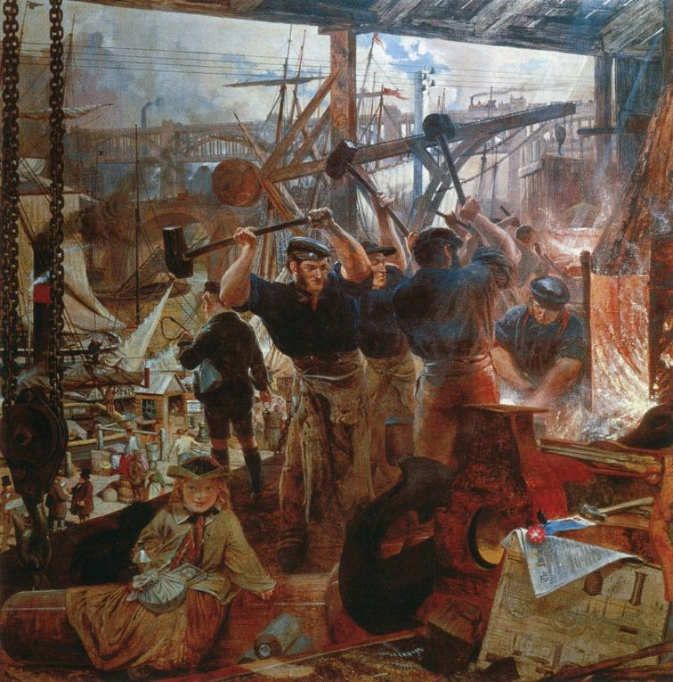
Land in this economic sense means not just usable open land for industry to build on. It also means the natural resources that were needed for industrialization. Coal was needed in vast quantities for the Industrial Revolution to fuel steam engines and furnaces. Iron ore was necessary for machines, buildings, and bridges. England had an abundance of both as well has rivers for inland transportation.
Labor represents a large workforce for the industries. With a booming population from higher food production and the enclosure movement pushing people to cities, England’s industries had more than enough workers. Finally, capitol is the money needed to fund industry. A well-developed banking system in Great Britain allowed for loans to invest in industries and
A Stable Government and Economy
Finally, the Industrial Revolution flourished in Great Britain for political reasons. While England was often at war, all of these conflicts took place outside of the country. As a result, life in the country was relatively peaceful. The last major political upheaval was the Glorious Revolution in 1688 and a period of peace and stability followed when other nations were undergoing revolutions or political changes.
Additionally, the political system of England encouraged trade and entrepreneurship. A straightforward legal system allowed the formation of joint-stock companies, enforced property rights, and respected patents for inventions.
Finally, the Great Reform Act was passed by Parliament in 1832. This granted seats in Parliament to large cities that had sprung up during the Industrial Revolution and removed seats from smaller areas that had been dominated by a wealthy patron. The Act also increased the electorate from about 400,000 to 650,000, making about one in five adult males eligible to vote.
Impact of the Industrial Revolution
The Industrial Revolution also led to an unprecedented rise in the rate of population growth. Britain’s population grew 280% between the years 1550–1820, while the rest of Western Europe grew 50–80%. Additionally, Great Britain became the world’s leading commercial nation, controlling a global trading empire with colonies in North America and the Caribbean, and with political influence on the Indian subcontinent.

© Students of History - https://www.teacherspayteachers.com/Store/Students-Of-History

