Name

Inventions of the Industrial Revolution

INVENTION | INVENTOR | DESCRIPTION AND IMPORTANCE | PICTURE
Spinning Jenny

Steam Engine
 | Eli Whitney
Steel Process |  |  | 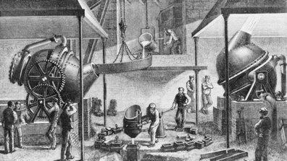
Smallpox Vaccine

 | Guglielmo Marconi
Phonograph

Germ Theory

 | Alexander Graham Bell
Airplane

