Name Period

APWH Review 2020

UNIT 3: Land-Based Empires 1450-1750

3.1 Empires Expand
Review videos
- Heimler 3.1
- KA: Ottoman, Safavid, and Mughal Empires

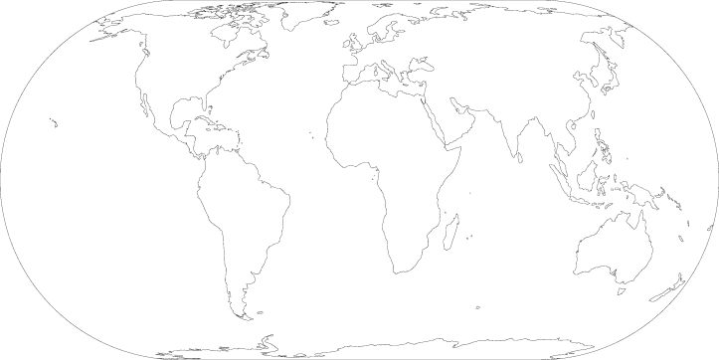

Identify: (1) The Manchu empire in Central and East Asia, (2) the Mughal Empire in South and Central Asia, (3) the Ottoman empire in Southern Europe, the Middle East and North Africa(4) the Safavid Empire in the Middle East), (5) the Aztec Empire in the Americas, (6) the Inca empire in the Americas and (7) the Songhai Empire in West Afrcia

Pick three of the land based empires above and describe how it expanded and the effect of its expansion.

1. Empire Selected_____________________
Cause of expansion

Effect of expansion

2. Empire Selected_____________________
Cause of expansion

Effect of expansion

3. Empire Selected_____________________
Cause of expansion

Effect of expansion

3.2 Empires: Administration
Review videos
- Heimler 3.2
- CCWH2: The Mughal Empire and Historical Reputation
- KA: Mughal Rule in India

Explain how the Ottoman use of the Devshirme system enabled them to maintain centralized control over their populations

Explain how either European notions of the divine right, Mexicia practice of human sacrifice OR Songhai promotion of Islam helped legitimize
the government.

Explain how either the Mughal, or Ottoman, or Mexica or Ming used tax collection systems to forward state power (see acorn)

In the space below, identify each example of art and monumental architecture, its associated empire, and how it was used to legitimize a ruler’s power.

Identify
Associated Empire

How was it used to legitimize a ruler’s power?

Identify | 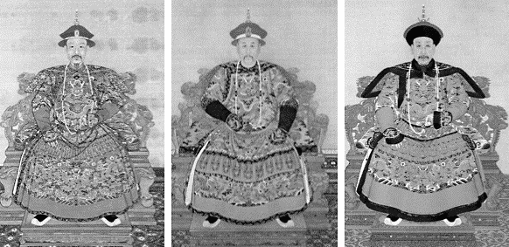
Associated Empire

How was it used to legitimize a ruler’s power?

Identify

Associated Empire

How was it used to legitimize a ruler’s power?

Identify | 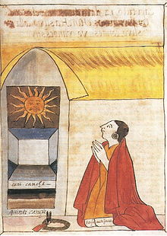
Associated Empire

How was it used to legitimize a ruler’s power?

3.3 Empires: Belief Systems
Review videos
- Heimler 3.3
- CCEH #2: Florence and the Renaissance
- CCWH2: Luther and the Protestant Reformation
- CCCEH #6: Reformation and Consequences
- CCEH #13: Absolute Monarchy
- KA: Continuity-Sikhism connections to Hinduism and Islam
Define the Protestant Reformation and describe of its effects | Define the Catholic Reformation and describe of its effects
Describe Sikhism | What are Sunni and Shi’a?
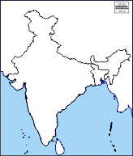  Locate the origins of Sikhism on this map | Explain how political rivalries intensified the split between Sunni and Shia

Review videos
- Heimler 3.4

