Name Period

APWH Review 2020

Unit 4: Transoceanic Empires 1450-1750
4.1 Technological Innovations from 1450-1750
Review videos
- Heimler 4.1
- CCWH #22: The Renaissance: Was it a thing?
- CCEH #4: The Age of Exploration
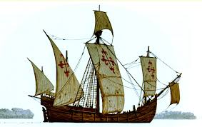  What and how did new tools and ship designs helped trade and travel during this time? | 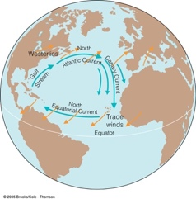  How did improved understanding of wind and current patterns help trade and travel during this time?
What is this technological development?  Explain how European use was influenced by cross cultural interactions with the Classical, and/or Islamic and/or Asian Worlds. |  | 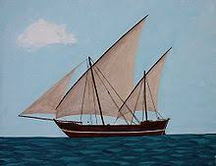
What is this technological development?  Explain how European use was influenced by cross cultural interactions with the Classical, and/or Islamic and/or Asian Worlds. |  | 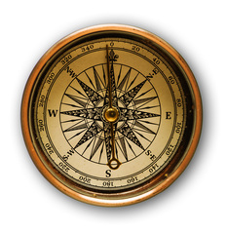

4.2 Explorations: Causes and Events from 1450-1750
Review videos
- Heimler 4.2
- CCWH #27: The Amazing Life and Strange Death of Captain Cook
Explain how Columbus’s voyages could be an example of state-sponsored transoceanic maritime exploration in this era | 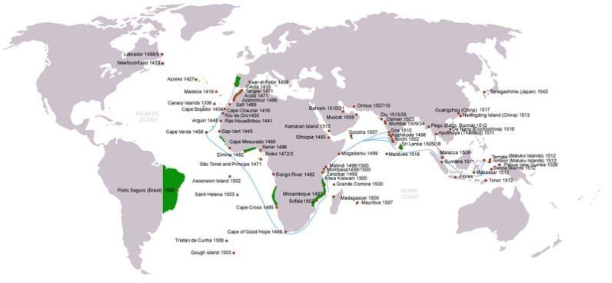  This map could be used to show how _________________________ development of maritime technology and navigational skills led to increased travel to and trade with Africa and Asia and resulted in the construction of a global ___________ _________ empire.
How did the Spanish voyages across the Atlantic increase European interest in transoceanic travel and trade?

Provide evidence for the statement “Northern Atlantic crossings taken by the English, French, and Dutch often had the goal of finding alternative sailing routes to Asia.”

4.3 Columbian Exchange
Review videos
- Heimler 4.3
- CCWH #23: The Columbian Exchange
- CCEH #5: Expansion and Consequences
- CCWH #24: The Atlantic Slave Trade
Define the Columbian Exchange

On the Map below, draw(add images) or list some of the things exchanged.

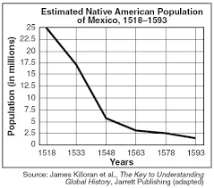  What does this map illustrate about the Columbian Exchange? | 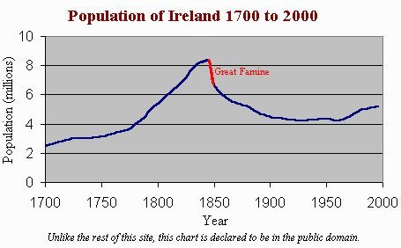  What does this map illustrate about the Columbian Exchange ?

4.4 Maritime Empires were established
Review videos
- Heimler 4.4
- KA: Spain, Portugal, and the creation of a global economy

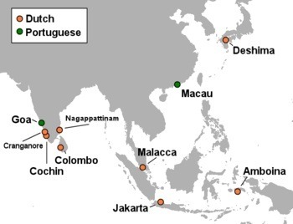  This map shows what kind of empire? | Pick either Ming China or Tokugawa Japan and describe its restrictive or isolationist trade policies

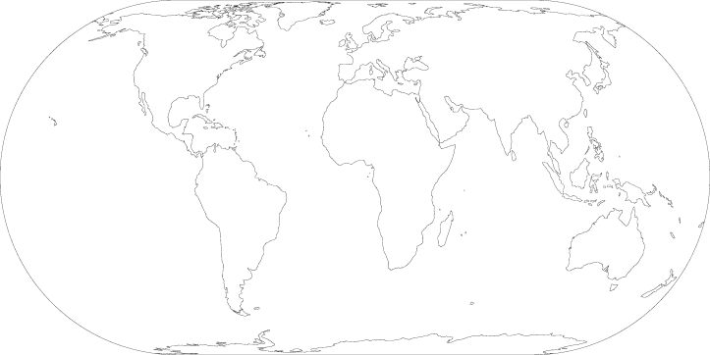
Identify the maritime empires of the Portuguese, the Spanish, the Dutch, the French and the British, as well as the expanded Asante and Kongo states
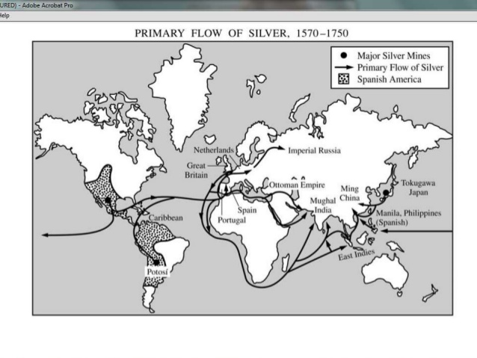
Use the map on the right to indicate the global flow of silver on the map above

How did Europeans impact existing trade routes in the Indian Ocean in this era? | How did colonial economies use the preexisting mit’a system? | What is chattel slavery and how did colonial economies rely on it?
What is indentured servitude? | What is the encomienda system? | What is the hacienda system?

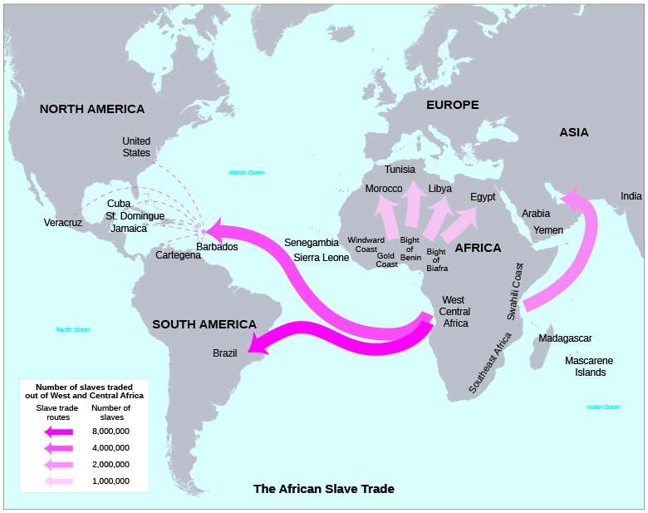 | This map shows that ________________in Africa continued in its traditional forms, including incorporation of slaves into households and the export of slaves to the _________________and the ___________ ____________regions
The growth of the ____________ _____________ increased demand for slaves in the Americas.

Describe one demographic change that resulted in Africa.

Describe one demographic change that resulted in the Americas.

Describe one cultural change in the Americas | Describe one social change in the Americas.

4.5 Maritime Empires Maintained and Developed
Review videos
- Heimler 4.5
- CCWH2: Capitalism and the Dutch East India Company
- CCWH #25: The Spanish Empire. Silver, and Runaway Inflation
Define mercantilism. | Explain how mercantilist polies lead rulers to claim overseas empires | Explain how mercantilist polices were used by Europeans to control their economies.
Explain how joint stock companies made it easier for rulers and merchants to finance exploration. |  |  | Joint stock companies were used by rulers to _____________ against one another in global trade.

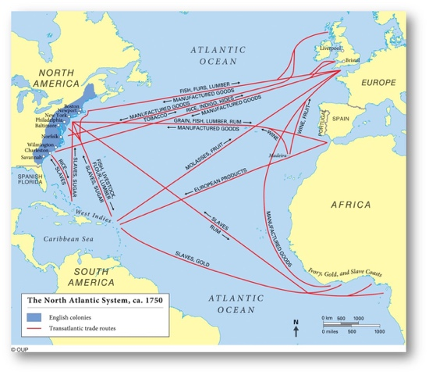 | The Atlantic system involved the movement of ___________, __________ and labor, including _____________.  What went from Europe to Africa?  From Africa to the Americas?  From the Americas to Europe?  From Europe to the Americas?

From Wikipedia: A charted company is an association with investors or shareholders and incorporated and granted (often exclusive) rights by royal charter (or similar instrument of government) for the purpose of trade, exploration, and colonization  What is an example of one? | List the illustrative examples of intensified peasant and artisan labor and the places associated with them

The Atlantic trading system involved the movement of labor—including slaves—and the mixing of African, American, and European cultures and peoples, with all parties contributing to this cultural synthesis. . . .In some cases, the increase and intensification of interactions between newly connected hemispheres expanded the reach and furthered development of existing religions, and contributed to religious conflicts and the development of syncretic belief systems and practices.
Describe a specific piece of evidence that could be used to support anything from this passage

4.6 Internal and External Challenges to State Power from 1450-1750
Review videos
- Heimler 4.6
- CCEH #8: Commerce, Agriculture, and Slavery

Describe any one of the following examples of local resistance:  1. Pueblo Revolts, 2. Fronde, 3. Cossack revolts, 4. Maratha conflict against the Mughals, 5. Ana Nzinga’s resistance, 6. Metacom’s War | Describe one of the following examples of slave resistance.  1. establishment of Maroon societies in the Caribbean and Brazil,  2. North American slave resistance

4.7 Changing Social Hierarchies from 1450 to 1750
Review videos
- Heimler 4.7
Describe the changes and continuities of one of the following existing elites during this time period  1. Ottoman timars, 2. Russian boyars, 3. European nobility | Contrast the treatment of Jews on the Iberian Peninsula with their treatment in the Ottoman Empire |  | Describe one practice used by either the Mughals or the Ottomans to accommodate religious diversity
What was the ethnic group that formed the elite in Qing China?  Pick the 2 terms in the illustration to the right that you are least sure of the definition of and define them  a)  b) |  | 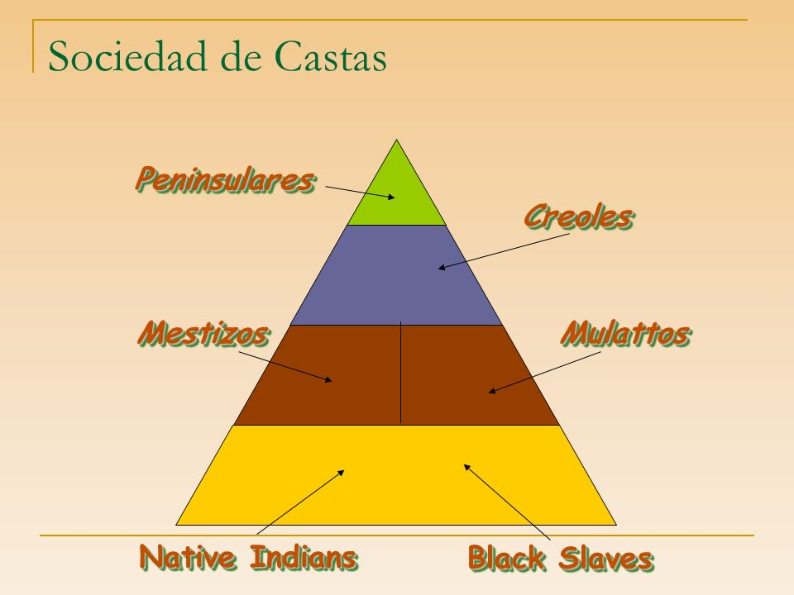

Review videos
- CCEH #12: Scientific Revolution

