Unit 9 vocabulary
EXAMPLE

DEFINITION | IMAGE | LINK WORD/PHRASE
Automobile | 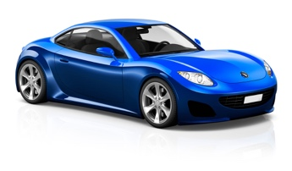 | Car  Or  I ride in the automobile to school in the mornings
A road vehicle, typically with 4 wheels and an engine with the purpose of moving people or goods

DEFINITION | IMAGE | LINK WORD/PHRASE
Industrialization
Enclosure movement
Factory system
Free enterprise
Socialism
Communism
Imperialism
Market Economy
Command Economy
Capital
Labor
Factors of production

