Standing Water
N a m e _________________________________D a t e _________________P e r i o d __________
Trench Warfare
During WWI, heavy fighting took place on the Western Front, a 600-mile stretch from the English Channel to Switzerland. Troops dug trenches along the front. These trenches had to ensure the safety of the soldiers who would live, eat, sleep and fight there. Often these trench systems were as close as 20 meters away from the enemy who would face them across No Man’s Land. When they came out to fight, many were killed. Neither side won much ground. Study the two diagrams of trenches below and answer the following questions.

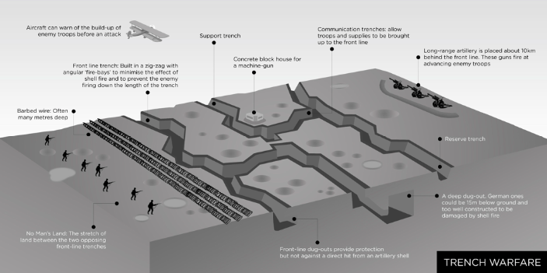

1. What is No Man’s Land? _______________________________
_____________________________________________________
2. What was the Dug-out used for? _________________________
_____________________________________________________
3. Why were the trenches built zig zag and not in straight lines?
_____________________________________________________
__________________________________________________________________________________________________
4. What was aircraft used for?__________________________________________________________________________
__________________________________________________________________________________________________
5. What do you think the Drainage Sump used for? ________________________________________________________
_________________________________________________________________________________________________
6. What do you think the Duckboard was used for? ________________________________________________________
__________________________________________________________________________________________________
7. What likely problems soldiers living in trenches may have to endure? ________________________________________
__________________________________________________________________________________________________
Weapons of Mass Destruction: The Industrialization of War
World War I was the first large scale war to be fought by industrialized weapons, causing massive destructiveness and death. Rapid-fire machine guns could fire up to 400 rounds per minute and had the fire power of 100 guns. They mowed down waves of soldiers, making it almost impossible to across no man’s land.
Artillery(large caliber guns) allowed troops to shell enemy lines and cities from more than 10 miles away. Each shell weighed up to 900 lbs.
In 1915, Germany began using poison gas that blinded or choked its victims or caused torturous burns and blisters. Later that year, the Allies also began to use gas. In 1916, Britain introduced a new weapon, the armored tank to break the stalemate of trench warfare. Mounted with machine guns, the tanks were designed to move across broken ground and through barbed wire. The first tanks moved slowly and broke down often. They did little to break the stalemate.
German artillery:
Howitzer (Big Bertha)

Both sides also used aircraft. At first, planes simply observed enemy troop movements. Then later they were loaded with machine guns. In 1915, Germany used zeppelins, large gas-filled balloons, to bomb the English coast. Submarines became a large threat during the war. German submarines, called Uboats sailed the Atlantic. The typical U-boat was 214 feet long, carried 35 men and 12 torpedoes, and could travel underwater for two hours at a time. They did enormous damage to the Allied side, sinking ships that carried vital supplies to Britain. To fight against submarine warfare, the Allies create convoys, or groups of merchant ships protected by warships that included torpedo boats with aerial reconnaissance equipment that could detect the movement of underwater submarines.
Zeppelins carried around 4,400 pounds of bombs, but were eventually abandoned as they were easy targets for artillery.

Chlorine and mustard gas was during the war. Chlorine would turn to acid in the lungs and soldiers would suffocate.

8. What is artillery? _________________________________________________________________________________
__________________________________________________________________________________________________
9. What is a Zeppelin and why were they deserted? ________________________________________________________
__________________________________________________________________________________________________
10. Why were tanks unsuccessful war machines in WWI? ___________________________________________________
__________________________________________________________________________________________________
11. How did the allies finally fight back against German U-boats? ____________________________________________
__________________________________________________________________________________________________
__________________________________________________________________________________________________
12. Which new weapon do you think was the most effective? Give evidence to support your answer. _________________
__________________________________________________________________________________________________
__________________________________________________________________________________________________

